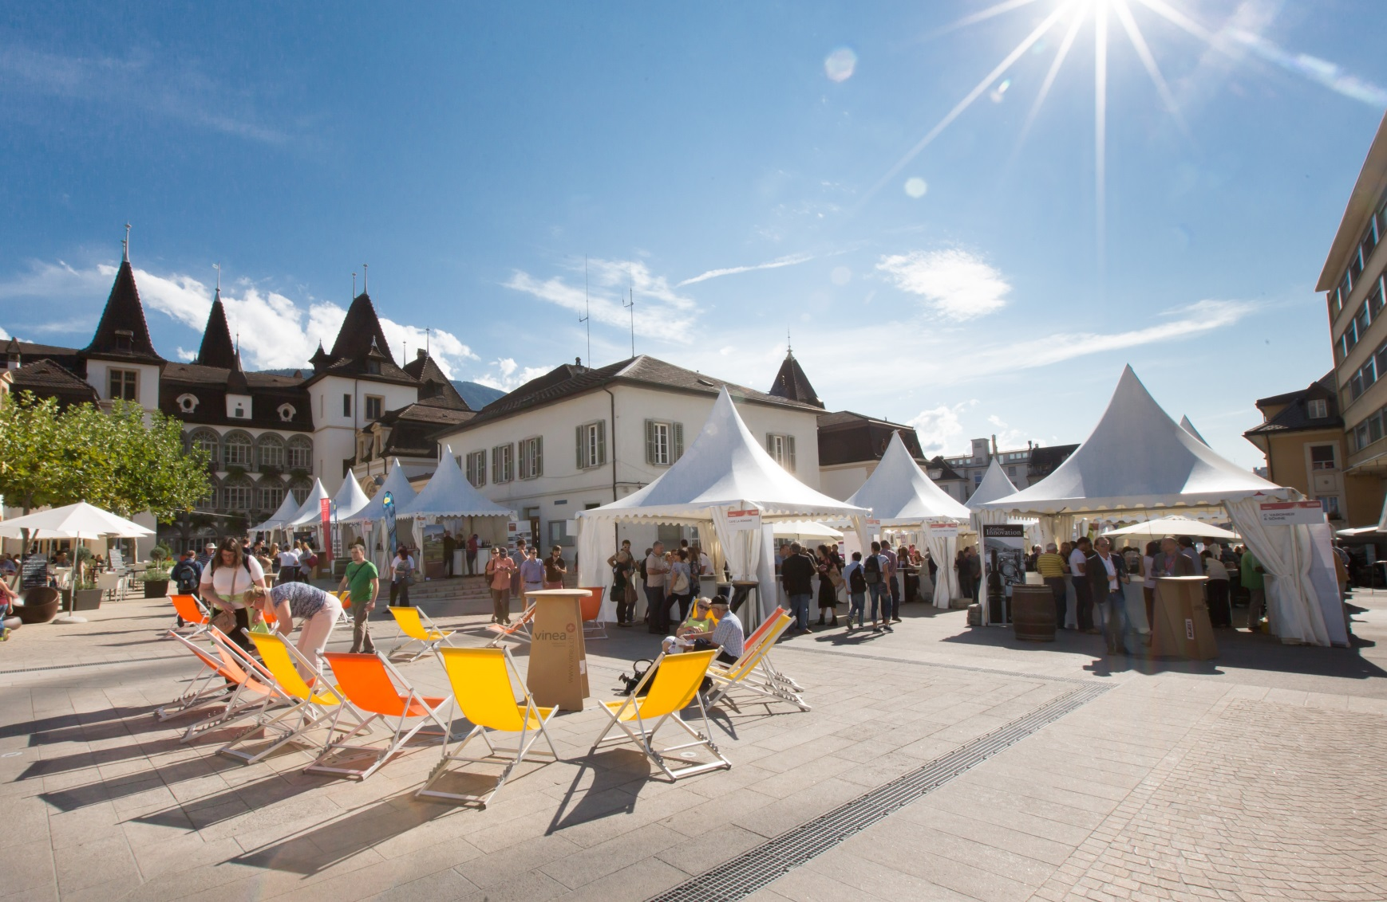
Become a sympathising member of the Association VINEA and benefit from:
- 1 free entrance for VINEA, Le Salon every year
- 1 invitation to the General Assembly of the Association VINEA

Membership fees: CHF 50.-

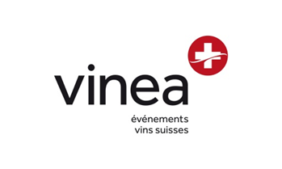
Interested? Subscribe directly with formulary below:
Company name : Click here to insert text.
Name / Surname : Click here to insert text.
Address : Click here to insert text.
NP / City : Click here to insert text.
Tel : Click here to insert text.
Portable : Click here to insert text.
E-mail : Click here to insert text.

Form to send back per email at info@vinea.ch or per post to the following address :
Association VINEA – Rue Beausite 4 – 3960 Sierre
For further information, feel free to contact the office at any time per telephone 0041 27 456 31 44 or per email at info@vinea.ch

