Association – Active member

Who is VINEA?
- Vision:
A multidisciplinary centre of excellence for the wine sector, VINEA's work aims to raise awareness of Swiss wines at national and international level, securing them the recognition they richly deserve by promoting them to both trade and consumer audiences.
- Mission:
VINEA organises consumer events, stages national and international competitions with wine experts and publishes information about the diversity of Switzerland's wine regions, raising awareness of Swiss wine both at home and abroad.
- Values:
VINEA believes that the success of Swiss viticulture lies in pooling the efforts and skills of the sector's members. VINEA puts specific emphasis on bringing together all members, with respect for each individual's defining characteristics.

Why to become an active member?
To enjoy benefits during events organized by VINEA:
- Discount of CHF 100.- for individuals or CHF 200.- for the associative pavilion during VINEA, Le Salon every year
- Exclusivity on VINEA on tour

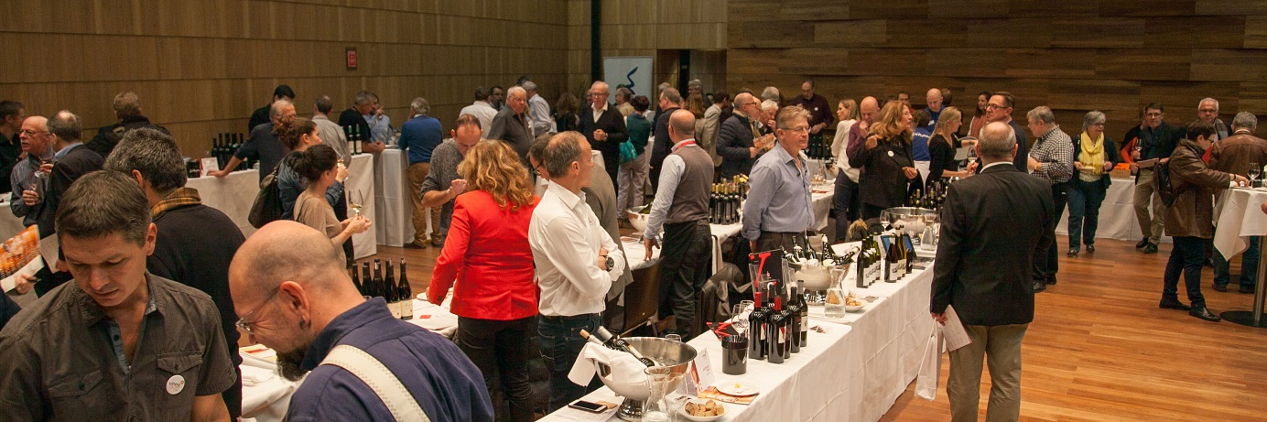

Price of the annual subscription: CHF 200.-

If you would like to subscribe, please fill up the form below:

Company name : Click here to insert text.
Name / Surname : Click here to insert text.
Address : Click here to insert text.
NP / City : Click here to insert text.
Tel : Click here to insert text.
Portable : Click here to insert text.
E-mail : Click here to insert text.

The office stays at your entire disposal for further information at 0041 27 456 31 44.

☐ I would like to pay by CCP at: CCP : 17-675671-3

☐ I would like to pay by credit card:
☐ Eurocard - Mastercard ☐ Visa

No credit card : Click here to insert text.
Name on the card : Click here to insert text.
Deadline : Click here to insert text.
Control number (CVC) : Click here to insert text.

Form to send back per email at info@vinea.ch or per poste at this address:
Association VINEA – Rue Beausite 4 – 3960 Sierre

I would like to become an active member of the Association VINEA and by my signature, I confirm my subscription to the Association VINEA and I pledge to pay the amount of CHF 200. - (exempt of VAT) per year. This subscription will be automatically renewed, except if we received an announced written resignation. The membership fees must be paid before the end of April of the current year to obtain all benefits.

Place and date: Click here to insert text. Signature: Click here to insert text.

